ASSIGNMENT 6.4

ENROLL NO:2403A52113

**Task Description #1:**

**•** Start a Python class named Student with attributes name, roll_number, and marks. Prompt GitHub Copilot to complete methods for displaying details and checking if marks are above average.

**Expected Outcome #1:**

**•** Completed class with Copilot-generated methods like display_details() and is_passed(), demonstrating use of if-else conditions.

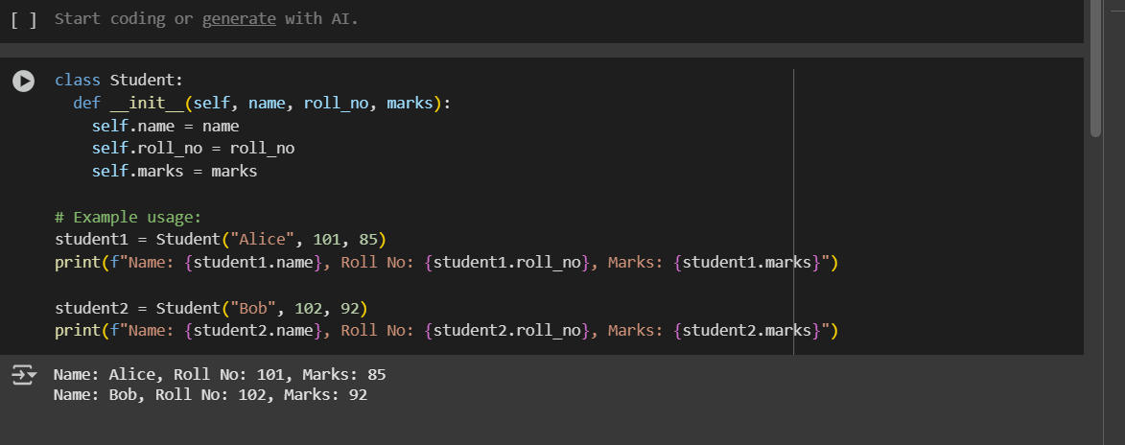

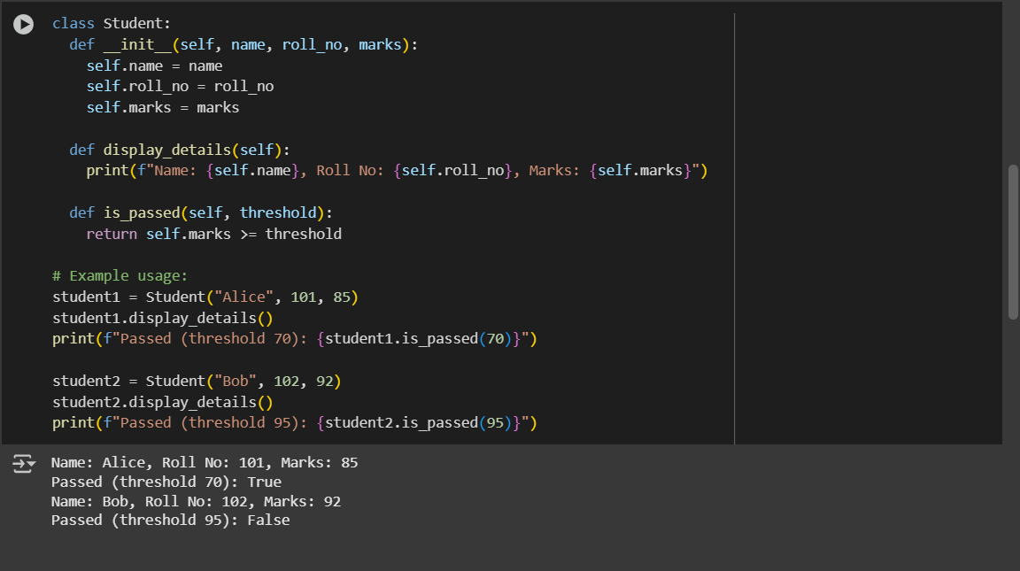

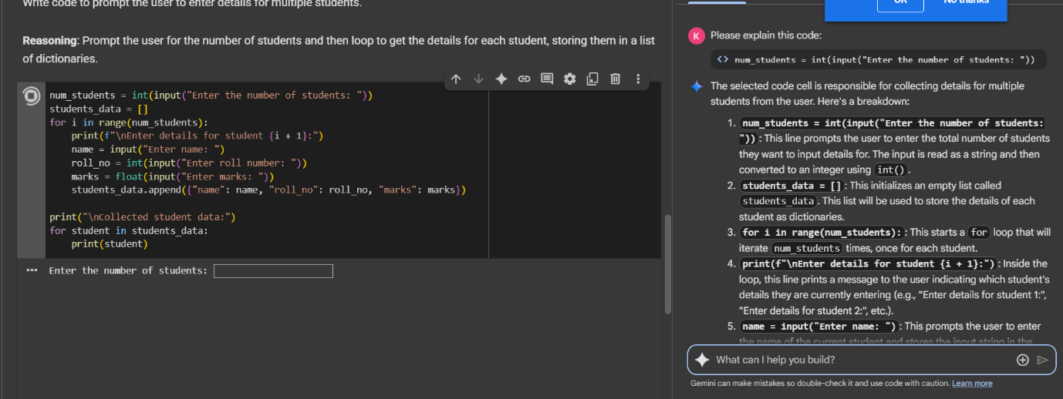

**Task Description #2:**

**•** Write the first two lines of a for loop to iterate through a list of numbers. Use a comment prompt to let Copilot suggest how to calculate and print the square of even numbers only.

**Expected Outcome #2:**

**•** A complete loop generated by Copilot with conditional logic (if number % 2 == 0) and appropriate output.

